Widecombe in the Moor Curriculum Map KS1 2021 -2023

 | Autumn | Spring | Summer
Year 1/2  Year A | 321 ...Blast Off!  Back down to Earth | Where my wellies take me … and beyond!  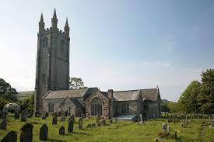 | Amazing women…  I do like to be beside the seaside  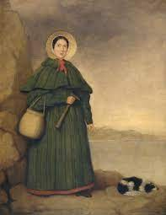
Hook or visit | Neil Armstrong/Space Dome | Dartmoor/Ghanaian Cookery | Mary Anning/Trip to the seaside
Year 1/2  Year B | The Great Fire of London  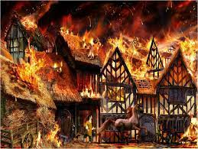 | Where can I go … and how can I get there? | How can we make a difference to our world?
Hook or visit | Guy Fawkes/Burn houses | Round Robin trip | Newbridge Conservation/Polar Regions

Widecombe in the Moor Curriculum Map KS2 2019 -2023

Year  A | Can you Survive in the Wild?  (Houses and Homes)  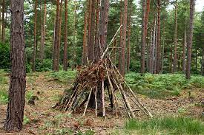 | Explorers and Exploration  Shackelton’s Journey  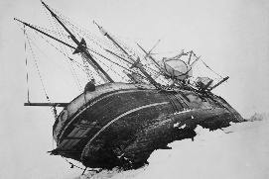 | The Olympics and Ancient Greece
Hook or visit | Trip to the Deer Farm/Ikea | Museum Visit | Olympic event/Sports Day
Year  B | Chocolate!  Ancient Mayans  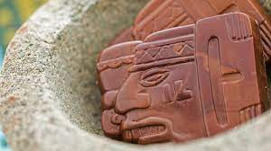 | Mighty Mountains | From Moor to Sea  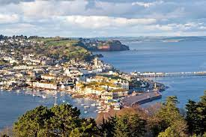  Stone Age to Bronze Age
Hook or visit | Chocolatier visitor/Design packaging | Mountaineer Visitor | Heatree/Source to Mouth of the River Lemon Trip
Year  C | What did the Romans do for us?  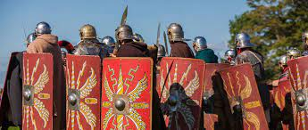 | Why are there no tropical rainforests on Dartmoor?  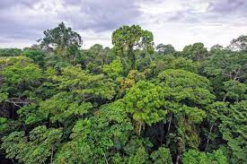 | Why did the Vikings and Saxons Invade Britain?  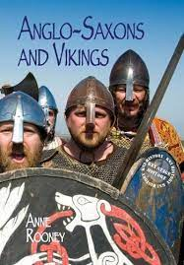
 | Roman Day/Storyteller | Eden Project | Invasion Storyteller
Year  D | Why do we remember? | Off with their heads! | What role did the Nile play in Ancient Egypt?  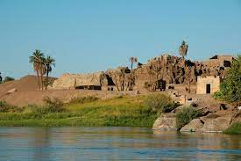
Hook or visit | Remembrance/Evacuation  Buckfastleigh Steam Train | Buckland Abbey | Visitor

